Uniform Check List
Compulsory School Uniform
David Luke black gold crested eco blazer boys or girls | 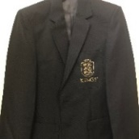 | Black slim leg trousers  Or  David Luke grey stitched down knife pleat skirt  DL972 | 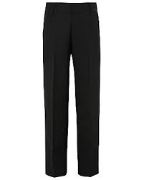
William turner striped tie with single crest | 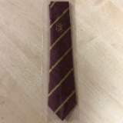 |  | 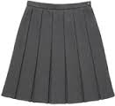
White shirt  long or short sleeves | 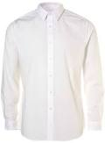 | Black or grey plain socks  or  Black grey or natural plain tights | 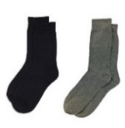
Black School Shoes | 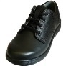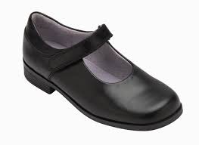 | School Rucksack | 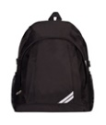
Compulsory PE Kit
Precision Attack black games shorts | 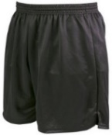 | Woodbank white polo shirt with gold embroidered crest | 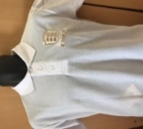
Halbro reversible maroon and white hooped Jersey with crest | 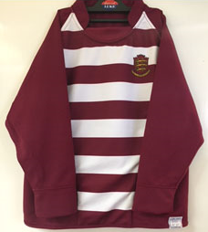 | Mitre Mercury contrast Maroon and white socks | 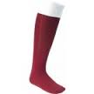
Plain black  swimsuit (girls)  Or  Swim shorts (boys) | 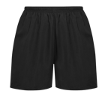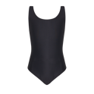 | Plain white sport socks | 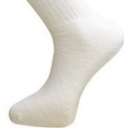
Studded boots | 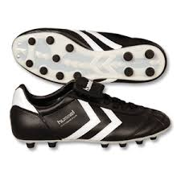 | Trainers | 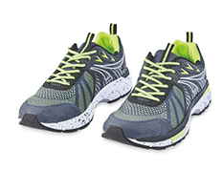
Compulsory Equipment
William Turner PE Bag RS10 (Must have name label) | 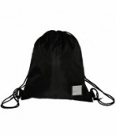 | Gum shield | 
Shin pads | 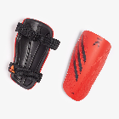 | Plain Apron | 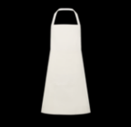
Optional Items
PE maroon sweatshirt with gold embroidered crest | 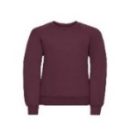 | School Uniform jumper Maroon Jumper with gold crest | 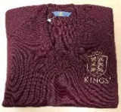
PE Plain black tracksuit bottoms and Waterproof sports jacket | 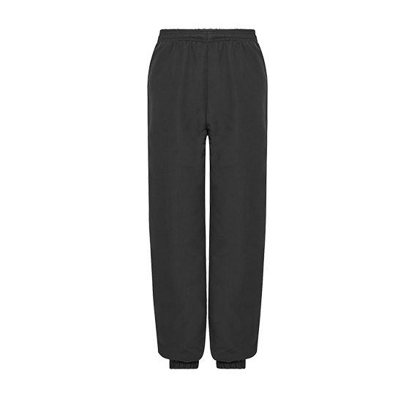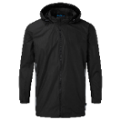 | Kings branded grey uniform shorts | 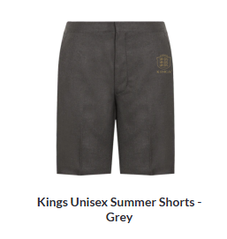
Items in red can only be purchased through Hewitts school shop online

