Dear Parent/Carer,
We are happy to announce some exciting news on the way we will be managing all trips and activities moving forward.
Introduction to myEVOLVE
For several years, the school has been using Hampshire County Council’s online system EVOLVE for planning, approving and managing educational visits. Moving forward, we will be using more of EVOLVE’s features which will allow you to view, book and pay for upcoming school trips and activities all in one place by introducing myEvolve to parents.
How it Works
From March, you will be sent details about forthcoming school trips and activities to the email address that you have registered with Kings’ School. This will appear to come from Hampshire County Council and will contain a secure link that will take you to the myEVOLVE online site. Here you can make a booking or register your interest for an activity, make a payment to secure the booking and also grant electronic consent, all in one place. Please keep an eye out for emails in your inbox from Hampshire County Council.
Whilst you can take action directly from the individual email invitations, you will also have the option to create a myEVOLVE account and we would strongly encourage everyone to do this.
By creating a myEVOLVE account, you can centrally manage all previous and forthcoming trips and activities, including browsing What’s On, managing your bookings, reviewing outstanding and previous consent forms and payments etc.
What’s more, once you have created an account you can download the myEVOLVE app from the Apple Store or Google Play Store and easily manage everything from your smart phone or tablet.
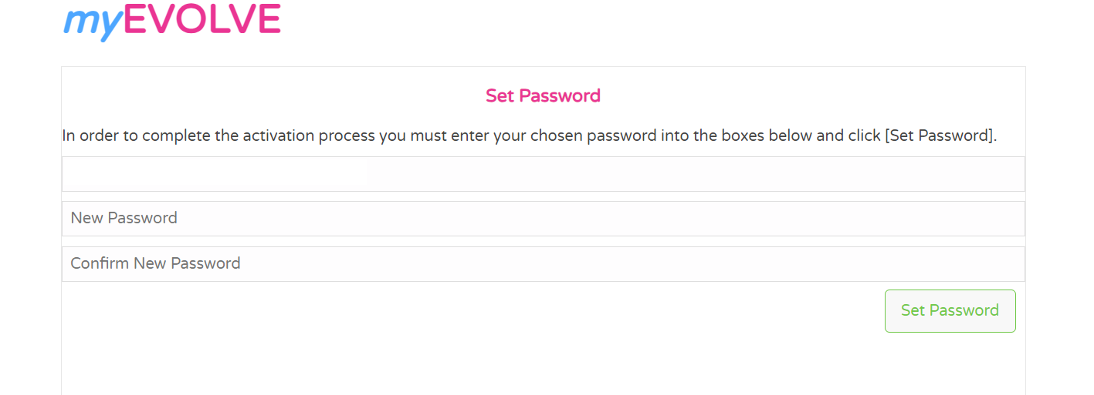
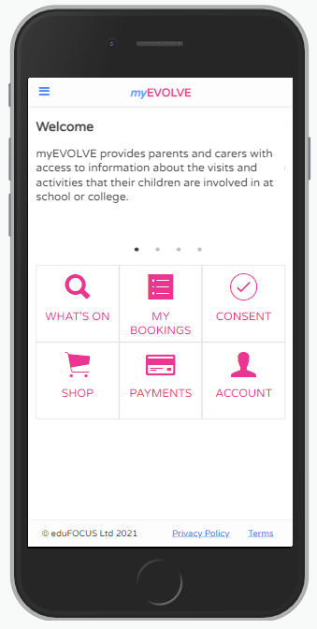

Next Steps
1. Please click on the activation link below to create an account.
https://evolve.edufocus.co.uk/myevolve/setup.asp?id=kings'

2. The link will take you to a page where you choose the option that you are a Parent/Carer.
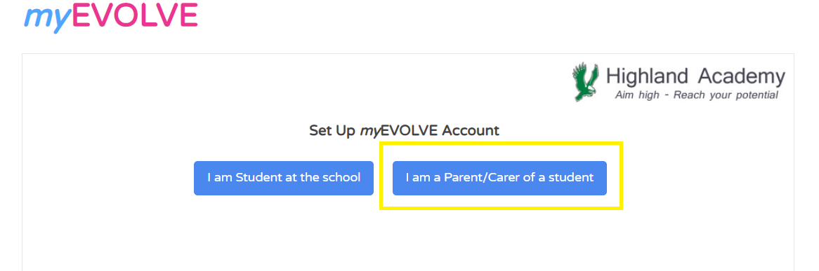
3. Add your email address, agree to the terms and click Set-Up Account. Please ensure it is the same email address that you have registered with Kings’ School. The link will not work if a different email address is entered.

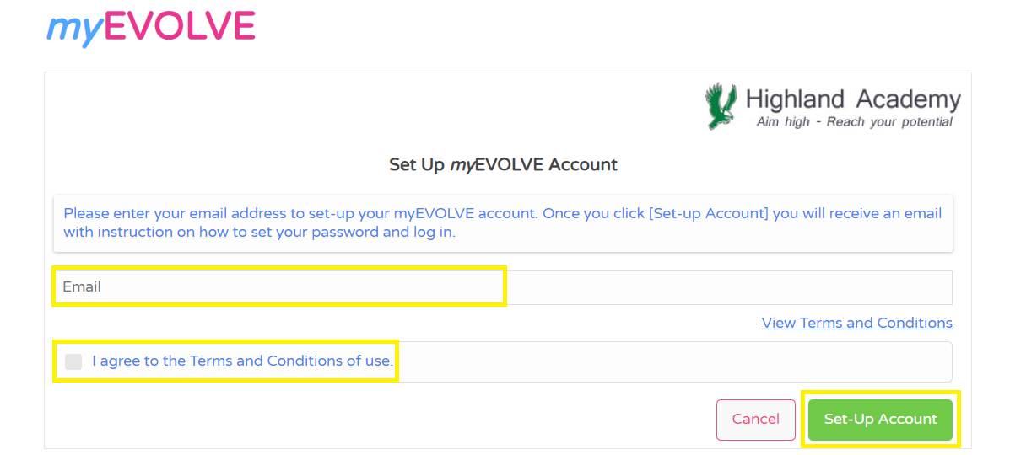

4. You will then be sent an email. Click on the link in the email.
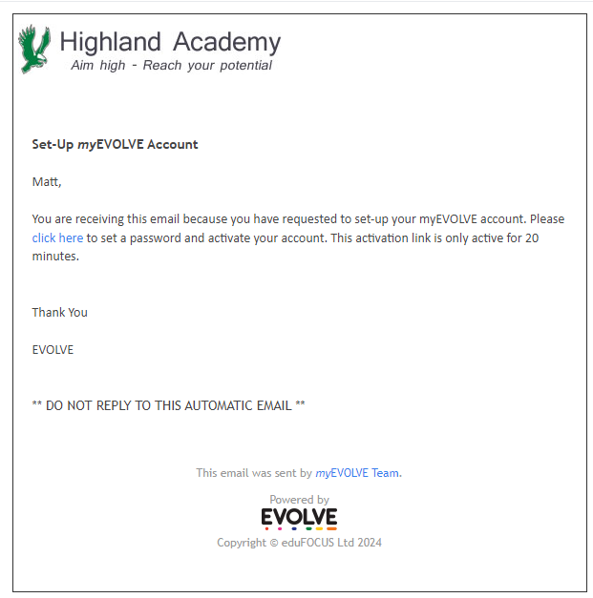

5. Add your password and confirm the password.

6. You have now created your myEVOLVE account and you will be taken to the log in page.
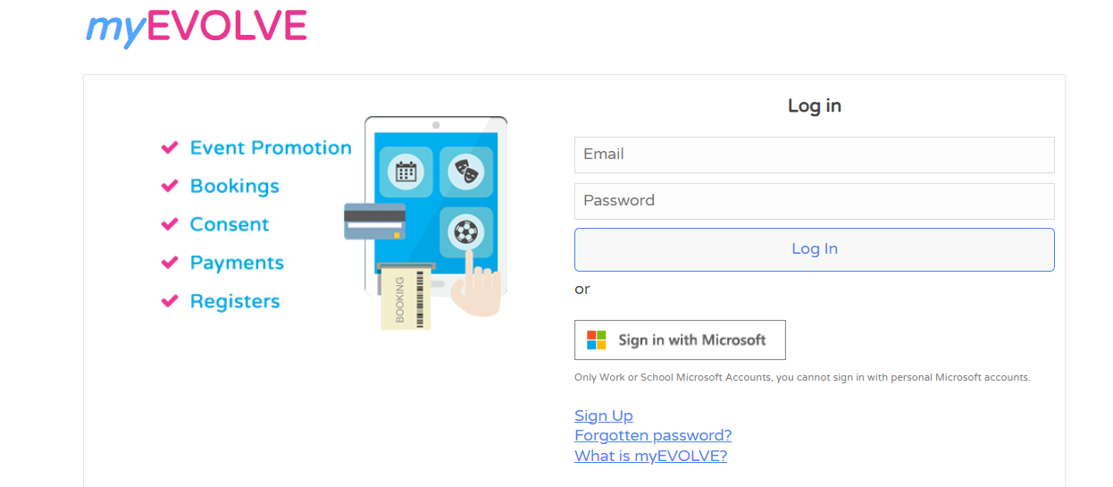

7. Please keep an eye out for emails in your inbox regarding bookings and consent and ensure that this email address is in your safe senders list: evolve.example@edufocus.co.uk
We would be grateful if you could please complete this process by Monday 2nd March.
Existing trips that have already been offered with places confirmed to pupils will continue to be managed via the current system including the use of ParentPay and Microsoft Forms.
Any trips or activities offered going forward will be managed using myEVOLVE. We will be using myEVOLVE for the upcoming Activity Days available to pupils in Years 7, 8 and 9
We are confident that myEVOLVE will allow Parents and Carers to have better visibility and control of pupil’s trips and activities, reducing the need for multiple different components.
If you have any queries or need any additional support, please send an email to trips@kings-hants.com FAO EVOLVE Support and we will be in touch.

Yours sincerely
Kings’ School

