

Kings’ School

Attendance Policy

Policy name | Attendance Policy | Owner / EIL
Hampshire model policy | No
Approved by Headteacher/SLT: | ADS | November 2025
Approved by Committee | Education Committee | November 2025
To be reviewed / Next review date | Annually | November 2026

- Aims

At Kings’ we believe that regular school attendance is essential if children are to achieve their full potential. We value the attendance of all pupils. Missing out on lessons leaves children vulnerable to falling behind and can put them at risk of wider harm. There is a wide range of evidence as to the health and wellbeing benefits of school-age education. Research commissioned by the Department for Education shows missing school for even a day can mean a child is less likely to achieve good grades, which can have a damaging effect on their life chances. As set out in this policy, we will work with families to identify the reasons for poor attendance and try to resolve any difficulties at the earliest opportunity. Our attendance policy aims to give clear guidance to staff, parents, pupils, and governors.

We are committed to meeting our obligation with regard to school attendance through our whole-school culture and ethos that values good attendance, including:

- Promote good attendance, enabling pupil’s achievement by establishing the
highest possible levels of attendance and punctuality.
- Recognise the key role of all staff in promoting good attendance.
- Provide a clear framework for monitoring and responding to pupil absences,
acting early to address patterns of absence.
- Building strong relationships with families to ensure pupils have the support
in place to attend school.
- Promote positive support systems and advocate multi-agency approaches to
improve attendance.
- Make parents aware of their legal responsibilities and ensure their children
have access to the education to which they are entitled.

We will also promote and support punctuality in attending lessons.

We recognise that attendance is a matter for the whole school community. Our Attendance Policy should not be viewed in isolation; it is a strand that runs through all aspects of school improvement, and should be read in conjunction with the following policies: Safeguarding, Anti-Bullying, Behaviour, SEND and Equality and Diversity. This policy also considers the Human Rights Act 1998, the Equality Act 2010, UN Convention on the Rights of the Child, and other relevant legislation.
2. Legal Framework

This policy meets the requirements of the Working together to improve school attendance - GOV.UK from the Department for Education (DfE), and refers to the DfE’s statutory guidance on School attendance parental responsibility measures. Section 7 of the Education Act 1996 states that parents must ensure that children of compulsory school age receive efficient full-time education suitable to their age, ability, and aptitude to any special educational needs they may have, either by regular attendance at school or otherwise.

A child is of compulsory school age at the beginning of the term following their 5th birthday. A child ceases to be of compulsory school age on the last Friday in June of the school year in which they reach the age of 16.

The government expects all schools and local authorities to:

• Promote good attendance and reduce absence, including persistent and severe absence.
• Ensure every pupil has access to full-time education to which they are entitled.
• Act early to address patterns of absence.

Parents are expected to perform their legal duty by ensuring their children of compulsory school age who are registered at school attend regularly. In accordance with the Education Act 1996, we will work with parents and carers and the Local Authority to ensure that parents and carers are supported to secure education for children of compulsory school age. Where required, we will formalise support and where necessary, work with the LA to use legal measures.

A “Parent” is defined as:
• Any natural parent, whether married or not.
• Any parent who, although not a natural parent, has parental responsibility as defined in the Children Act (1989) for a child or young person.
• Any person who, although not a natural parent, has care of a child or young person, including kinship carers.

  - Roles and responsibilities

At Kings’ School, we believe that improving school attendance is everyone’s business. It is a shared responsibility by governors, all school staff, parents, pupils, the wider school community and multi-agency partners. We aim to always work in partnership with our parents.

Role | Name | Contact Details
Senior Attendance Lead | Hayley Eiles | Kings.school@kings-winchester.hants.sch.uk
Attendance Officers  Year 7  Year 8  Year 9  Year 10  Year 11 | Sharon Clark  Catherine Brown  Leah Woodd  Catherine Misquith  Michelle Knight | Kings.school@kings-winchester.hants.sch.uk
Named Governor for Attendance | Sarah Henstock-Turner | Kings.school@kings-winchester.hants.sch.uk

3.1 The Governors of Kings’ School recognise the importance of school attendance and promotes it through the school’s ethos and across its policies.

They take an active role in attendance improvement by:

- Setting high expectations of all leaders, staff, pupils, and parents so that children attend school every day and are safeguarded.
- Identifying a member of the governing body/trustee to lead on attendance matters and ensuring that there is a named member of SLT to lead on attendance.
- Prioritising attendance in strategies, such as raising attainment, pupil premium, behaviour and combatting bullying, special educational needs and disabilities, wellbeing, and safeguarding.
- Ensuring school leaders fulfil expectations and statutory duties by rigorously evaluating the effectiveness of the school’s attendance procedures so that consistent attendance support is provided for all pupils.
- Ensuring the schools’ attendance management processes are delivered effectively, and that consistent attendance support is provided for pupils who require it most by prioritising the staff and resources needed. This includes ensuring schools engage and work effectively with the local authority School Attendance Support Team and wider local partners and services.
- Regularly reviewing attendance data, discussing, challenging trends, and helping school leaders focus improvement efforts on the individual pupils or cohorts who need it most.
- Ensuring high aspirations are maintained for all pupils and processes for support are adapted to the individual needs of pupils including those with long term illnesses, special educational needs and disabilities, pupils with a social worker, those pupils under the Virtual School and pupils from cohorts with historically lower attendance such as those eligible for free school meals.
- Ensuring all school staff receive adequate training on attendance and that relevant staff have access to opportunities to share and learn from good practice in other schools.
- Ensuring that attendance data is shared with the Local Authority or Department for Education in line with statutory reporting deadlines.
- Reviewing the school’s Attendance Policy on at least an annual basis, ensuring that the required resources are available to fully implement the policy, which is published and publicised so that it is easily accessible to pupils, parents and staff.
- Attendance data will be monitored by the Education Committee, a member of which will be the designated governor for Attendance.

3.2 The Senior Leadership Team at Kings’ School will:

- Actively promote the importance and value of good attendance to pupils and
their parents.
- Form and maintain positive relationships with pupils and parents.
- Ensure that there is a whole school approach which reinforces good school
attendance, with good teaching and learning experiences, with a whole school
culture that encourages all pupils to attend and to achieve.
- Make sure all teaching and non-teaching staff know the importance of good
attendance, are consistent in their communication with pupils and parents, and receive the training and professional development they need.
- Have a clear school attendance policy which all staff, pupils and parents understand. Monitor the implementation and effectiveness of the Attendance Policy and ensure that the policy is reviewed annually.
- Ensure the school have accurate, complete admission and attendance registers and have effective day to day processes in place to follow-up absence.
- Regularly monitor and analyse attendance and absence data to identify pupils or cohorts that require support with their attendance and put effective strategies in place.
- Share information and work collaboratively with other schools in the area, local authorities, and other partners where a pupil’s absence is at risk of becoming persistent or severe.
- Ensure that there is a named Senior Attendance Champion to lead on attendance and allocate sufficient time and resource.
- Ensure representation at the termly school attendance supporting meetings with the local authority, focusing on those pupils with severe absence, making sure a regularly reviewed plan is in place.

3.3 All staff at Kings’ School will:

- Actively promote the importance and value of good attendance to pupils and their parents.
- Form positive relationships with pupils and parents.
- Contribute to a whole school approach which reinforces good school attendance; with good teaching and learning experiences that encourage all pupils to attend and to achieve.
- Know the importance of good attendance, are consistent in their communication with pupils and parents, and receive the training and professional development they need.

The member of staff responsible for attendance will work to further develop relationships with families to bring about improved attendance. This may involve seeking multi-agency support.

3.4 Kings’ School requests that parents:

- Take a positive interest in their child’s work and educational progress.
- Ensure their child has regular attendance at school.
- Instil the value of education and regular school attendance within the home environment.
- Contact the school if their child is absent to let them know the reason why and the expected date of return.
- Avoid unnecessary absences; for example, by making medical and dental appointments for outside of school hours.
- Ask the school for help if their child is experiencing difficulties with any aspect of their schoolwork or home and family life.
- Inform the school of any change in circumstances that may impact on their child’s attendance.
- Provide the school with more than 1 emergency contact number for their child
- Support the school by becoming involved in their child’s education, forming a positive relationship with school, and acknowledging the importance of children receiving the same messages from both school and home.
- Maintain effective routines at home to support good attendance.
- Attend all meetings requested to discuss attendance issues.

Further information can be found at:
https://www.hants.gov.uk/educationandlearning/behaviour-attendance-parents (Appendix 3)

3.5 Pupils will:

- Be aware of the school’s attendance policy and when and where they are required to attend. This will be communicated to them by school staff, parents and through the school timetable.
- Speak to their class teacher or another member of staff if they are experiencing difficulties at school or at home which may impact on their attendance.
- Attend all lessons ready to learn, on time for the class and with the appropriate equipment.
- Sign in at reception if they arrive late or when leaving school site during school hours. This will help the school to monitor attendance and keep accurate records for the child’s individual attendance. This is also vital for health and safety in the event of a school Evacuation (Appendix 4).

4. Categorising Absence and Attendance

When marking our registers, we will apply the national codes as outlined and regulated by the Department for Education guidance to accurately record and report attendance.

4.1 Leave of Absence

Since September 2013, changes to Government regulations and guidance mean that Headteachers can no longer authorise leave of absence unless there are exceptional circumstances. Generally, the DfE does not consider a need or desire for a holiday or other absence for the purpose of leisure and recreation to be an exceptional circumstance. Leave of absence should not be granted for a pupil to take part in a protest activity during school hours. All absences associated with a holiday or other absence for the purpose of leisure and recreation during term time will be marked as unauthorised within the register. Any parents known to have removed their child from school for the sole purpose of a holiday or other absence for the purpose of leisure and recreation may be referred to the Local Authority and be issued with a penalty notice fine or referred to the Local Authority to consider prosecution. We believe that children need to be in school for all sessions so that they can make the most progress possible. However, we do understand that there are times where a parent may legitimately request leave of absence for a child due to ‘exceptional circumstances’. At Kings’ School, leave of absence is only granted at the discretion of the Headteacher and shall not be granted unless there are ‘exceptional circumstances’. Kings’ School will respond to all applications for leave of absence in writing (Appendix 2).

Parents wishing to apply for leave of absence during term time must apply in writing to the Headteacher at least a month before the planned leave (see Appendix 1). If a written request for leave of absence is not completed and the leave is taken without a request being submitted, the leave will not be considered by the Headteacher, and it will be marked as unauthorised. Kings’ will treat each application individually and discuss with you the circumstances of the application before a decision is made. Retrospective requests will not be considered and therefore will result in the absence being categorised as unauthorised. A penalty notice request or a referral for prosecution may be submitted to the Local Authority if: -

• The parent fails to submit a leave of absence request in advance of taking the leave.
• An application for a leave of absence is not agreed by the Headteacher but is still taken.
• A longer period is taken more than the agreed number of days.

When absence is granted by the Headteacher, the parents will need to agree a date of return. If a pupil fails to return on the expected date and contact is not received from, or made with the parents, school will seek advice from the Local Authority. This could result in possible children missing from education procedures being instigated. The 1996 Education Act also sets out the circumstances in which a pupil has not failed to attend school regularly and therefore the parent has not committed an offence. Paragraphs 4.2, 4.3, 4.4 below are examples of these exceptions. The full list is set out in Appendix 5.

4.2 Medical Appointments and absence due to illness

Parents should try to make appointments outside of school hours wherever possible. Where appointments during school time are unavoidable, we ask that parent notifies the school in advance of the appointment wherever possible. The pupil should only be out of school for the minimum amount of time necessary for the appointment. In most circumstances, a child should not miss a whole day at school for an appointment. If a pupil must attend a medical appointment during the school day, they must sign out at Reception. No pupil will be allowed to leave the school site without parental confirmation.

In line with Department for Education guidance, if we do have a genuine concern about the authenticity of the illness, we may ask the parent to provide medical evidence, such as a prescription, appointment card, or other appropriate form of evidence. If the school is not satisfied about the authenticity of the illness, the absence will be recorded as unauthorised. Where a child has an emerging pattern of non-attendance, we will seek to discuss the reasons for absence with the child’s parent. We will invite parents to attend a support meeting as an appropriate early intervention strategy. As part of this support, we may seek consent from parents and the pupil as appropriate to make a referral to the School Nursing Team and/or to liaise with the child’s healthcare professional.

Where a pupil has a verified and chronic health condition, we will aim to work with parents to ensure children have access to education and provide appropriate support in line with Supporting pupils with medical conditions at school and Hampshire policies regarding supporting children with health issues Behaviour and attendance resources for schools / Hampshire County Council (hants.gov.uk).

4.3 Pupil Absence for the purposes of Religious Observance

Kings’ School acknowledges the multi-faith nature of British society and recognises that, on some occasions, religious festivals may fall outside school holiday periods or weekends and is recognised as such by a relevant religious authority. Where this occurs, the school will consider either authorising the pupil absence or making special leave for religious observance. Parents are requested to give advance notice to the school. Working together to improve school attendance - GOV.UK (www.gov.uk) page 86.

4.4 Parent travelling for occupational purposes

The pupil is a mobile child, and their parent(s) is travelling in the course of their trade or business and the pupil is travelling with them. A mobile child is a child of compulsory school age who has no fixed abode and whose parent(s) is engaged in a trade or business of such a nature as to require them to travel from place to place. To ensure we can effectively support all our pupils, we ask that parents:
• Advise the school of their forthcoming travelling patterns as soon as these are known and before they happen; and
• Inform the school regarding proposed return dates.

4.5 Unauthorised Absence

Absence will not be authorised unless parents have provided a satisfactory explanation, and it is accepted as such by the school. The decision to authorise absences is at the discretion of the Headteacher. Examples of unsatisfactory explanations include but are not limited to:
• A pupil’s or family member’s birthday.
  - Shopping for uniforms.
• Arrangements or appointments for cutting the pupil’s hair.
• Closure of a sibling’s school for INSET (or other) purposes.
• An unwillingness to attend school, or inability to attend owing to inadequate personal/family organisation.
• A refusal to attend school on health grounds but where the pupil is considered well enough to attend.
• Absences taken without the authorisation of the school

5. Our Procedures

5.1 Register Keeping and Recording

The Education (Pupil Registration) (England) Regulations 2006, as amended by 2016 regulations, require schools to take an attendance register twice a day, once at the start of the morning session and then again during the afternoon session. For the purpose of this policy, the school defines:

“Absence” as:
• Arrival at school after the register has closed.
• Not attending school for any reason.

“Regular” attendance as:
• Attendance at every session the school is open to pupils unless their absence has been authorised.

Pupils must arrive in school by 8.40 am on each school day in order to be in tutor time for 8.45am.

The register for the first session will be taken at 8.45 am and will be kept open until 9.15 am. The register for the second session will be taken at 1.15 pm and will be kept open until 1.30 pm.

Registers are legal records, and all schools must preserve every entry in the attendance or admission register for 6 years from the date the data was entered. As the attendance register is a record of the pupils present at the time it was taken, the register should only routinely be amended where the reason for absence cannot be established at the time it is taken, and it is subsequently necessary to correct the entry. Where amendments are made, all schools must ensure the register shows the original entry, the amended entry, the reason for the amendment, the date on which the amendment was made, and the name of the person who made the amendment. On each occasion the register is taken the appropriate national attendance and absence code must be entered for every pupil (of both compulsory and non-compulsory school age) whose name is listed in the admission register at the time. The codes enable schools to record and monitor attendance and absence in a consistent way and are used to collect statistics. The data helps schools, local authorities, and the government gain a greater understanding of the delivery of education and the level of, and reason for, absence.

Reporting to parents/carers

The school will regularly inform parents about their child’s attendance and absence levels. This is done via each child’s school reports, and can be accessed live via the ClassCharts app.

5.2 Late Arrival at School

At Kings’ School, all pupils are expected to arrive on time for every day of the school year. The school day begins at 8.45. We advise all parents to ensure their child is on site prior to this. The school register will be taken at 8.45. All pupils arriving after this time are required to report to pupil reception where they will be held in the auditorium until 9.10am where they can be supported by members of the pastoral team. Pupils who arrive after 9.10am will be expected to sign in at main reception and provide a reason for their absence. If their arrival is before 9.15 it will be recorded as late - L code (Late before the close of register).

The school register will officially close at 9.15. All pupils arriving on or after this time will be marked as having an unauthorised absence for the session - U code (Late after the close of register). This is categorised as an unauthorised absence for the session. Parents will be contacted to discuss any patterns of late arrival. Repeated arrival after the close of registration will result in appropriate interventions being instigated and may also result in a penalty notice being issued or prosecution.

Registers are legal records, and all schools must preserve every entry in the attendance or admission register for 6 years from the date the data was entered. As the attendance register is a record of the pupils present at the time it was taken, the register should only routinely be amended where the reason for absence cannot be established at the time it is taken and it is subsequently necessary to correct the entry. Where amendments are made, all schools must ensure the register shows the original entry, the amended entry, the reason for the amendment, the date on which the amendment was made, and the name of the person who made the amendment.

5.3 Expected absence procedure for parents:

A parent has a legal responsibility to ensure that their child attends school regularly. If a child is unavoidably absent from school, parents are expected to contact school by 8.30am on the morning of the first day of absence and on each subsequent day, Parents are requested to use ClassCharts to identify the reason for absence and the expected date of return.

We will mark absence due to illness as authorised unless the school has a genuine concern about the authenticity of the illness.

If the authenticity of the illness is in doubt, the school may ask the pupil’s parent/carer to provide medical evidence, such as a doctor’s note, prescription, appointment card or other appropriate form of evidence. We will not ask for medical evidence unnecessarily.

If the school is not satisfied about the authenticity of the illness, the absence will be recorded as unauthorised and parents/carers will be notified of this in advance.

5.4 Unexplained absence

Where any pupil we expect to attend school does not attend, or stops attending, without reason, the school will:
- Contact the pupil’s parent/carer on the morning of the first day of unexplained absence to ascertain the reason. If the school cannot reach any of the pupil’s emergency contacts, the school may make a home visit or involve an external agency such as the police
- Identify whether the absence is approved or not
- Identify the correct attendance code to use and input it as soon as the reason for absence is ascertained – this will be no later than 5 working days after the session
- Call the parent/carer on each day that the absence continues without explanation to ensure proper safeguarding action is taken where necessary. If absence continues, the school will consider involving the local authority or other external agency
- Look for unexplained absence that may also become apparent during the school day. When a pupil unexpectedly fails to attend a lesson, the teacher will notify the Positive Behaviour Coordinators, School Office and Year Officers. There will be a check of possible explanations (Matron, Year Offices etc) before contacting parents/carers to alert them of possible truancy. The timings of this check and of contacting parents/carers will depend on specific circumstances, with a balance to be struck between unjustified distress to parents/carers and the risks to the pupil
- Telephone home if a pupil leaves the school without permission

5.5 In certain circumstances the school may also:

• Visit the home of the pupil.
• Write to the parents of a pupil to highlight attendance or punctuality issues.
  - Invite parents to discuss how school can support the family to make improvement.
• Refer to Inclusion Support Service for support, guidance, and advice.
• Refer to the Local Authority for joint enquiries to be made to establish the whereabouts of the child through Inclusion Support Service (ISS) | Education and learning | Hampshire County Council and Behaviour and attendance resources for schools | Education and learning | Hampshire County Council
• Refer to the Local Authority to consider issuing a penalty notice or to consider prosecution when all other interventions have failed, or an unauthorised leave of absence has been taken.
• Refer the matter to an appropriate external agency for multi-agency support, such as implementing a Family Support Plan or consulting with the Children’s Social Care or the police, where there are safeguarding concerns.

5.6 Attendance Rewards & Interventions

The school has a staged approach to supporting attendance through its rewards and recognition structure (Appendix 6)

Attendance is monitored regularly by a range of stakeholders. These Stakeholders follow the school absence procedure (Appendix 7).

Monitor and Analyse attendance

Kings’ School will:
• Monitor and analyse weekly attendance patterns and trends and deliver intervention and support in a targeted way to pupils and families.
• Use this analysis to provide regular attendance reports to class teachers or tutors to facilitate discussions with pupils and to leaders (including the Year Officers, Special Educational Needs Coordinators and Designated Safeguarding Leads.
• Undertake frequent individual level analysis to identify the pupils who need support and focus staff efforts on developing targeted actions for those cases.
• Conduct thorough analysis of half-termly, termly, and full year data to identify patterns and trends. This includes analysis of pupils and cohorts and identifying patterns in uses of certain codes, days of poor attendance and where appropriate, subjects which have low lesson attendance.
• Benchmark attendance data (at whole school, year group and cohort level) against local, regional, and national levels to identify areas of focus for improvement.
• Devise specific strategies to address areas of poor attendance identified through data.
• Monitor in the data the impact of school wide attendance efforts, including any specific strategies implemented. The findings are then used to evaluate approaches or inform future strategies.
• Provide data and reports to support the work of the governing body and local authority when appropriate.

At Kings’ School we will investigate any pupils who are on track to be persistently absent (PA) and will not wait until their attendance is below 90%.

“Persistent absenteeism” (PA) as:
• Missing 10% or more of schooling across the year for any reason.

“Severe absence” (SA) as:
• Missing 50% or more of schooling across the year for any reason.

5.7 Support Systems

At Kings’ School we recognise that poor attendance can be an indication of difficulties in a family’s life. This may be related to problems at home and or in school. Parents are encouraged to inform school of any difficulties or changes in circumstances that may affect their child’s attendance and/or behaviour in school, for example: bereavement, divorce/separation, emerging health concerns. This will help the school identify any additional support that may be required.

We also recognise that some pupils are more likely to require additional support to attain good attendance. The school will implement a range of strategies to support improved attendance based on the individual needs and circumstances of the child. We will use a range of strategies using members of our Pastoral Team.

To plan the correct support, we will always liaise with parents and pupils to investigate the concerns and devise a plan to support the child’s regular attendance. Support offered to families will be child-centred and planned in discussion and agreement with both parents and pupils.

5.8 Persistent Absence, Severe Absence and the use of legal interventions

A pupil becomes a ‘persistent absentee’ (PA) when their attendance drops to 90% and below for any reason. Over a full academic year this would be 38 sessions (19 days). Absence at this level could cause considerable damage to a child’s educational outcomes.

A pupil becomes a ‘severe absentee’ (SA) when their attendance drops to 50% and below for any reason. Over a full academic year this would be 190 sessions (95 days). Absence at this level is causing considerable damage to a child’s educational outcomes.

The attendance of all pupils at our school are monitored to identify children who are PA, or are on track to becoming PA. Where emerging concerns are identified we will instigate appropriate and timely interventions as outlined in the section above. Referrals may also be made to external agencies for targeted support. Inclusion Support Service (ISS) | Education and learning | Hampshire County Council

If parents fail to engage with support and their child continues to have unsatisfactory attendance/ punctuality, a request may be made to the Local Authority to pursue legal proceedings either through a penalty notice, consideration of an Education Supervision Order or prosecution via the Magistrates’ Court.

Parents found guilty of failing to secure their child’s regular attendance at school under the provisions of the Education Act 1996, will receive a criminal record and a maximum penalty of a £1,000 fine under a Section 444 (1) offence or a £2,500 fine or up to a 3-month prison sentence, under a Section 444 (1A) offence. In line with Hampshire County Council guidance, we will notify the Inclusion Support Service of all reduced timetables as soon as a plan has been agreed.

6. Related Policies

To underpin the values and ethos of our school and our intent to ensure that pupils at our school attend school regularly and reach their full potential, the following policies are integral to this approach:
- Safeguarding
- Child protection.
- Supporting pupils with medical conditions.
- Admissions.
- Anti-bullying.
- Exclusion.
- Special educational needs and disability (SEND).
- Behaviour
- Equality and Diversity

7. Statutory Framework

This policy has been devised in accordance with the following legislation and guidance:

- Working together to improve school attendance - GOV.UK
- School attendance parental responsibility measures, DfE (January 2015)
- Children missing education - GOV.UK
- Keeping children safe in education - GOV.UK
- Working together to safeguard children - GOV.UK

8. Appendices The following pages contain appendices relevant to this policy.
Appendix 1: Example leave of absence request form Request to authorise absence from school due to exceptional circumstances

Schools are only able to authorise absence from school in exceptional circumstances. In making a request for an authorised absence from school you will need to explain why the circumstances are exceptional. Please note: There is no general right to authorised absence for a family holiday. If you take your child out of school without permission the absence will be unauthorised, and the local authority will consider legal action.

You are advised not to make any arrangements until your request has been considered.

Section A – to the headteacher, I wish to apply for

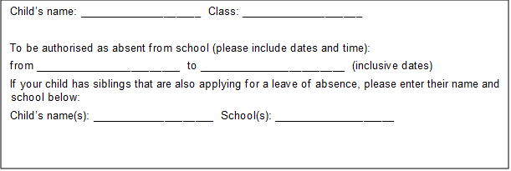

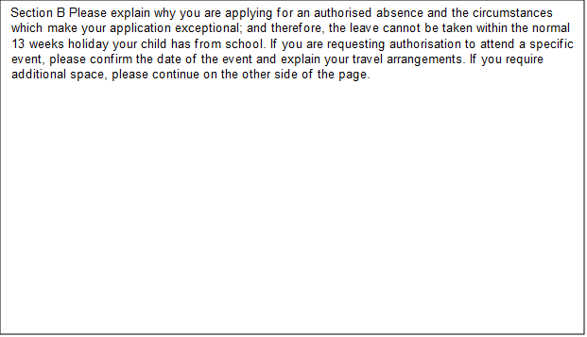

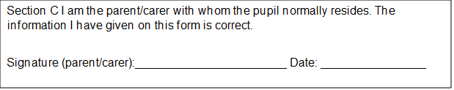

Education (Pupil Registration) (England) Regulations 2006 have been amended (as of 1 September 2013) to prohibit the proprietor (headteacher) of a maintained school granting leave of absence to a pupil except where an application has been made in advance and the proprietor considers that there are exceptional circumstances relating to the application.

Section D – for school use only

Tick as appropriate.

Request approved for ___ number of days from the dates and times_________________

A personal discussion with you is requested. Please contact:______________________

Request not approved as the circumstances are not considered to constitute an exceptional reason and/or the impact of this absence will affect your child’s educational progress.

PLEASE NOTE: This leave of absence form serves as a Warning to parent/carer. Any unauthorised absence during this period may be subject to a Penalty Notice OR may result in a prosecution if two previous penalty notices have been issued in a rolling three-year period.

A Penalty Notice may be issued per parent/carer, per child (i.e. if two parents have two children this may result in four Penalty Notices – two Penalty Notices per parent)

Headteacher: __________________________ Date:____________________

Current attendance rate:_____________________

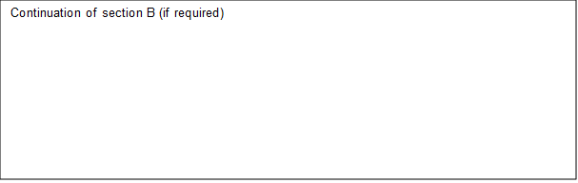

Appendix 2: Example reply to leave of absence request

Dear (parent’s name)

RE: Absence during term time – Child Name (Child DOB)

Thank you for your application for absence in term time for Child’s name. Whilst we appreciate your circumstances, Kings’ School do not approve any absences during term time unless they are due to exceptional circumstances as per the guidance from the Department of Education.

The rationale behind this decision is that the Government has provided evidence that satisfactory progress at school is highly dependent on attendance.

Kings’ School works closely with the Inclusion Support Service and if you choose to take your child out of school for the above unauthorised leave, we will notify the local authority and further action including legal action may be considered.

Please note that such a Penalty is issued to each parent for each child taken out of school. A Penalty Notice is a fine of £80 which increases to £160 if not paid within the first 21 days. Thereafter if the Penalty remains unpaid after 28 days this may result in legal action be taken against you. Parents have a duty to ensure their child’s regular attendance at school and failure to do so is an offence under Section 444(1) of the Education Act 1996.

I have noted the dates that Child Name will be absent from Kings’ School, Dates of leave and the registers will be marked with the G code (unauthorised family holiday) for this period. If you would like to discuss the matter further, please contact the school on 01962861161.

Yours sincerely

Headteacher

Appendix 3: Attendance Policy Quick Guide for Parents

Attendance Policy Quick Guide for Parents

We expect pupils to attend school for 100% of the academic year. You can support your child to have excellent attendance by taking these steps:

• Ensure your child arrives on time for school every day and is ready to learn. Arriving after registration is recorded as an unauthorised absence. Pupils must be in school by 08.45 am.
• If your child appears to be only slightly unwell, send them in to school. We have staff who will contact you if their condition deteriorates.
• B ook any medical appointments outside of school hours. If this is unavoidable, please book for as late in the afternoon as possible and inform the school of appointments in advance.
• Supply a copy of the appointment card or hospital letter if your child has an appointment during school hours.

If your child becomes reluctant to go to school or you need help, please contact the school immediately; we are more likely to be able to work together to solve any problems if we act early.

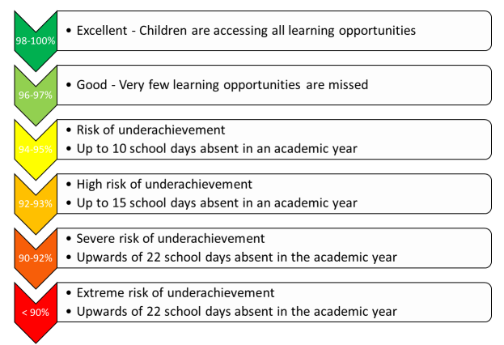

‘On the day’ absences: what should I do if my child is not ‘fit’ to go into school?

On each day your child is unfit to come to school, please report this absence using the ClassCharts App or by phoning the school attendance line 01962861161 (Option 1) before 8:20am to let us know. In the message you must leave your child’s full name, year and tutor group and give the specific reason for absence. The information you give will be recorded on our official register.

Leave of Absence There may be exceptional circumstances where you need to request a leave of absence for your child. Please use our ‘Leave of absence request’ form to make these types of requests. The form should be submitted in advance of the leave of absence. You will receive a written response to advise if the request has been granted or declined.

Punctuality
Pupils are expected to arrive on time for school in the morning and for every lesson during the day. Your child is late to school if they are not in their Tutor group by 08.45am. The Government remains very clear that no child should miss school apart from in exceptional circumstances and schools must continue to take steps to reduce absence to support children’s attainment. I hope we can count on your support in this matter. Please contact your child’s Year Office if you require any support with ensuring your child’s regular school attendance.
Appendix 4: Attendance Policy Quick Guide for pupils

Attendance Policy Quick Guide for Pupils

Roles and responsibilities:
All members of the school community at Kings’ have roles and responsibilities in promoting and ensuring good attendance and punctuality.

Role of the pupils: Pupils have a responsibility to themselves and others to play a positive role in the life of the school and to make the most of the education opportunities available.

All pupils will:

• Ensure that they attend school regularly and on time.
• Be aware of their current attendance record and targets.
• Be aware of the consequences of poor attendance or truancy.
• Arrive to lessons punctually.
• Not leave school without permission.
• Inform a trusted adult if they feel that they are being bullied or feel unhappy in school.

Appendix 5: Attendance codes

The following codes are taken from Working Together to Improve School Attendance

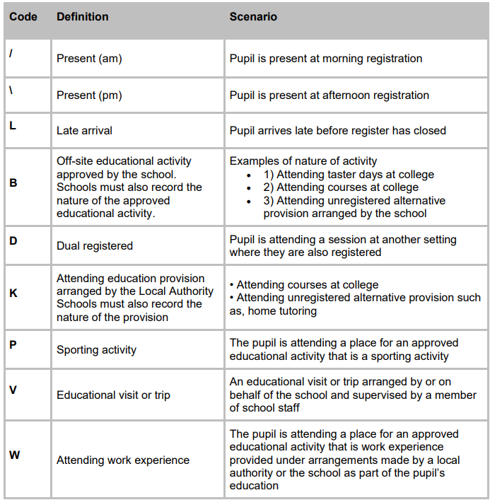

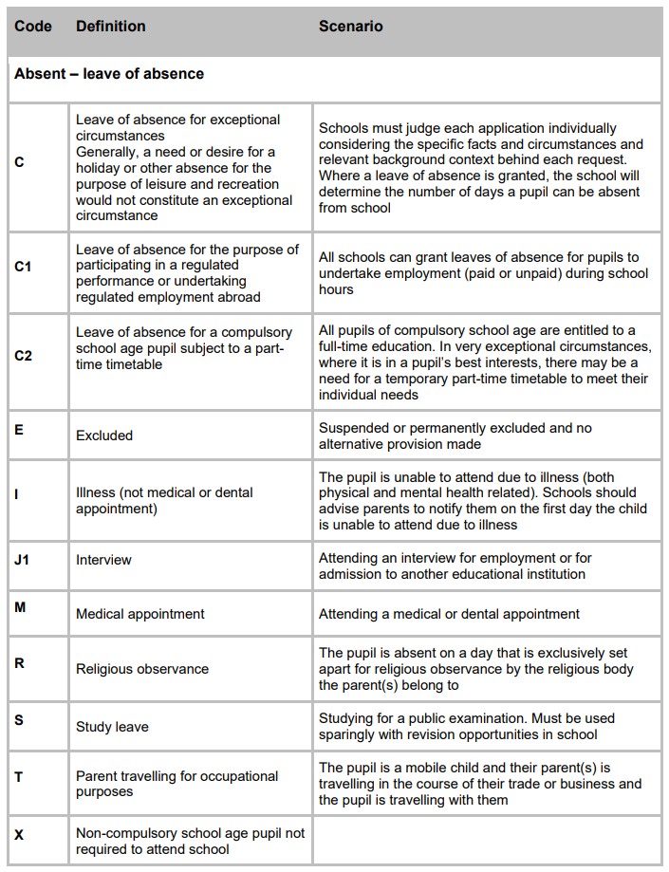

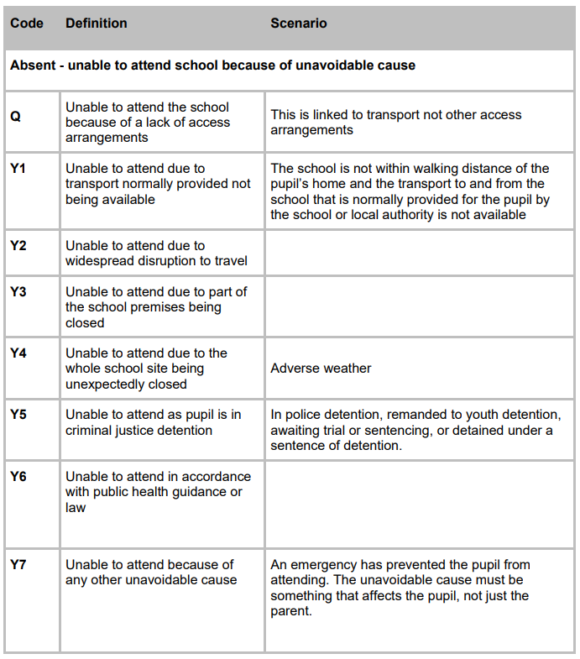

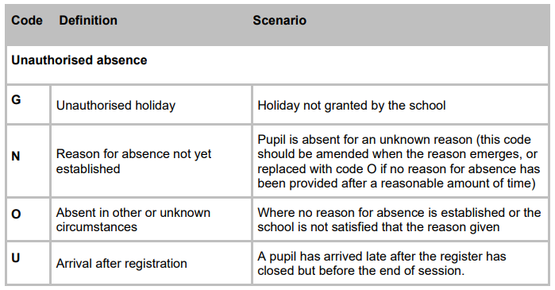

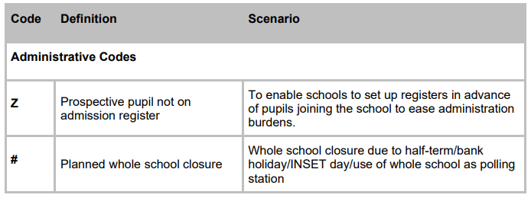
Appendix 6 – Recognition and Rewards Model

Value | Reward | Daily / Weekly | Termly | Annually
Earn Success | Attendance | Credit / postcard / phone call – end of week (YO / Tutor) | Earn Success -  Bronze / Silver / Gold Badge  +  Certificate  Given out in Celebration Assemblies | Gold Badge Winners  Prom Marquee  Silver Badge Winners  Celebration Lunch
Earn Success | Attitude to Learning | Credit / postcard / phone call - end of lessons (CT)
Earn Success | Homework | Credit / postcard / phone call - end of lessons (CT)
Earn Success | Progress | Credit / postcard / phone call - end of lessons (CT)
Discover Brilliance in Everyone | House Participation | Credit / postcard / phone call – end of week (HoH / Tutor) | Earn Success -  Bronze / Silver / Gold Badge  +  Certificate  Given out in Celebration Assemblies | Gold Badge Winners  Prom Marquee  Tie  Silver Badge Winners  Celebration Lunch  Colours – PE /Music?  Tie
Discover Brilliance in Everyone | Co-curricular Participation | Credit / postcard / phone call – end of week (HoH / Tutor)
Make a Difference | Volunteering inc. leadership | Credit / postcard / phone call – end of week (All Staff) | Earn Success -  Bronze / Silver / Gold Badge  +  Certificate  Given out in Celebration Assemblies | Gold Badge Winners  Prom Marquee  Silver Badge Winners  Celebration Lunch  External performers  Headteachers Lunch
Make a Difference | External Activities
Be Kind, Humble and Act with Integrity | Being kind | Credit / postcard / phone call – end of week (All Staff) | Earn Success -  Bronze / Silver / Gold Badge  +  Certificate  Given out in Celebration Assemblies | Gold Badge Winners  Prom Marquee  Silver Badge Winners  Celebration Lunch
Unlimited Ambition | Positive Achievement Point Ratio | Credit / postcard / phone call (All Staff) | Earn Success -  Bronze / Silver / Gold Badge  +  Certificate  Given out in Celebration Assemblies | Gold Badge Winners  Prom Marquee  Silver Badge Winners  Celebration Lunch

Appendix 7 Pupil Absence procedure
