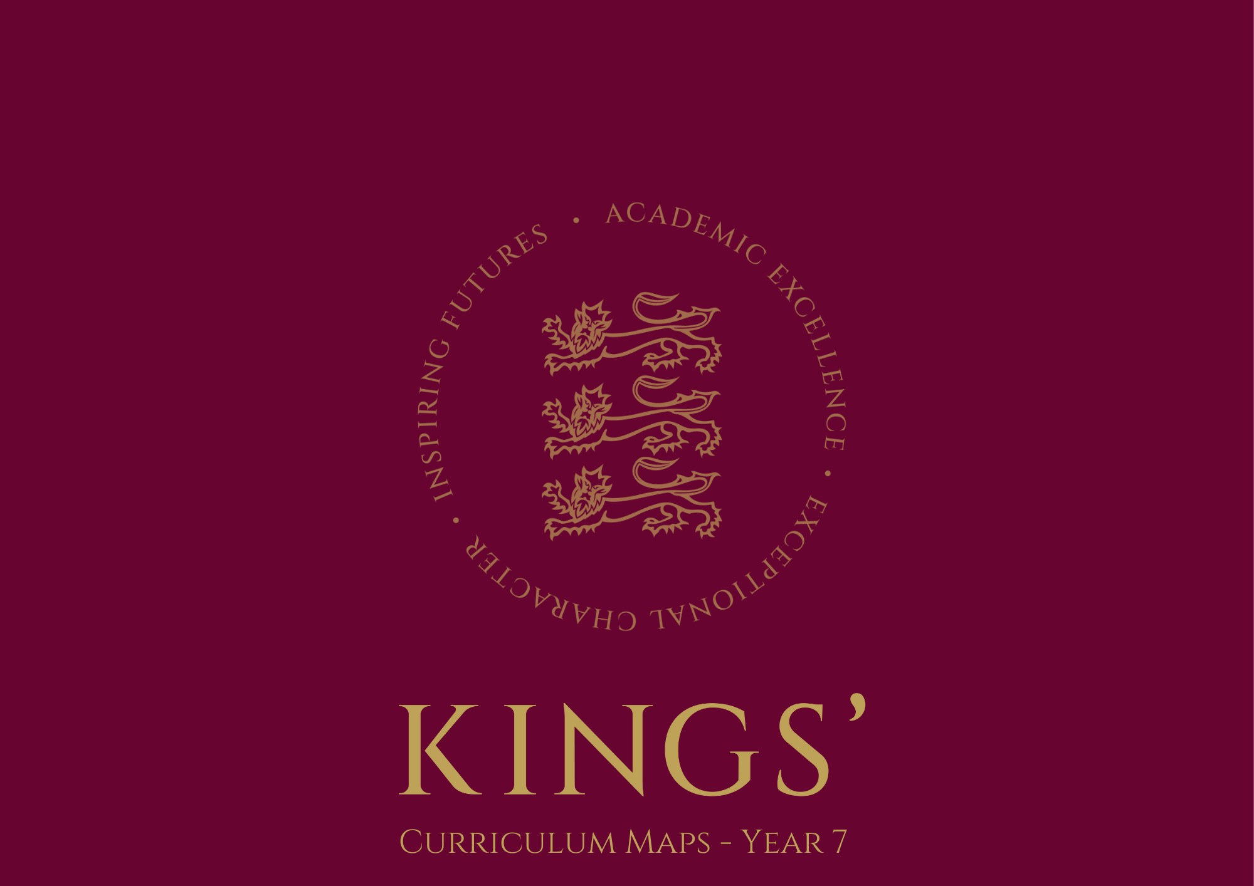

Curriculum Map – Year 7

 | Autumn Term –  1st half | Autumn Term – 2nd half | Spring Term –  1st half | Spring Term – 2nd half | Summer Term – 1st half | Summer Term – 2nd half
Art | Foundation Course 1:How to use pencil to apply shading, tone and form to make drawings look realistic and objects appear more three dimensional. | Foundation Course 2: How to use colour. Pupils will learn colour theory and learn how to mix colours and paint with them. They will explore primary colours, secondary colours, tertiary colours and analogous colours. They will create a colour wheel, and explore hot and cold colours. | Textiles projects - ‘Fantasy Fish’  Pupils will create an imaginative design of a fish, using their research and their artists investigations to inspire them. Their design will be painted on to calico using inks. Pupils will then use a range of textiles techniques to embellish the design– applique, stitching, beading.

 | Autumn Term –  1st half | Autumn Term – 2nd half | Spring Term –  1st half | Spring Term – 2nd half | Summer Term – 1st half | Summer Term – 2nd half
BEE | CATS/Card design/How computers work – Logic and computational thinking with the Baseline Assessment | Computational thinking and flow charts and enterprise day | Using computers  safely, effectively and responsibly – Digital Resilience | Animation – understanding how to use multimedia software and multi system project. | Programming a device  – Using microbits to help develop computational thinking | Spreadsheets – basic employability skills looking at how data is stored

 | Autumn Term –  1st half | Autumn Term – 2nd half | Spring Term –  1st half | Spring Term – 2nd half | Summer Term – 1st half | Summer Term – 2nd half
Drama | Greek Theatre –  An exploration of the History of  Theatre and the  dramatic forms & techniques used within Greek Theatre. The topic explores how Drama began, the impact of masks and  costume, and the role of the chorus and solo performance  through the exploration of Antigone, Oedipus  King Midas &  Lysistrata focusing on key performance skills, (Vocal, Physical, Spatial). | Pantomime –  Introduction to this  genre, developing  stock characters  and relationships  between characters  and an audience.  Application of  techniques learnt in  the foundation  course (voice  projection, body  posture, facial  expression, eye  contact) etc as well as the role of choral and solo performances through a scripted unit. | Science Fiction –  Exploring the genre  of Science Fiction  in theatre & film  through the  exploration of a  variety of  techniques covered  throughout the  year including cross  cutting and writing  for performance as  Monologues. | The Tempest’ -  Practical  exploration of  Shakespeare’s well  known text. Pupils  will explore the  characters, building  on performance  skills explored  through Pantomime  in a more refined  style. A variety of  strategies, &  techniques will  explore key  Themes linking in the use of cross cutting between contrasting scenes and characters. | Costume Design  in Performance –How to review & interpret the use of a single costume.  Pupils will learn  about the elements  of costume inc  fabric, fastenings  etc and recognise  the importance of these in theatrical  performance  having studied  Pantomime &  Elizabethan  Theatre. | Heroes – The sue of a variety of performance devices and techniques to explore heroic figures within society and their impact globally. This used allows students to recognise the impact of real-life heroes, teaching devising skills to create drama for change.

 | Autumn Term –  1st half | Autumn Term – 2nd half | Spring Term –  1st half | Spring Term – 2nd half | Summer Term – 1st half | Summer Term – 2nd half
English | Wonders of Winchester - A study of our local area. Language -  Assessment (Reading): Knowledge quiz and analysis of unseen extract | Narrative Poetry – Exploring the art of telling stories through poetry.  Assessment (Writing): Authoring a personal narrative poem.  Speak Out: Prepared reading from a chosen fiction book. | The Novel – Study and reading of a class text.  Assessment (Reading): Comprehension and inference-based analysis of an extract. | Villains – A study of literary villains through time.  Assessment (Writing): Writing of a key scene from a villain story.  Speak Out: Speech on a topic of personal choice. | The Play - Reading and Performing Drama - Writing and Reading  Assessment (Writing): Writing the opening of a new play. | Author Investigation - A study of literary greats.  Assessment (Reading): Reading comprehension and language analysis).  Speak Out: Present memorised recital of poetry or song lyrics.

 | Autumn Term –  1st half | Autumn Term –  2nd half | Spring Term –  1st half | Spring Term – 2nd half | Summer Term – 1st half | Summer Term – 2nd half
French | Literacy | Introducing yourself  (Name, age,  birthday, brothers  and sisters)  Likes and Dislikes,  Counting to 31,  Alphabet,  Pets and Colours,  Where You Live,  The Weather | Likes and Dislikes,  Describing Yourself  and Others  (Character and  appearance) | Telling the Time,  School subjects,  Opinions and  Reasons,  Describing your  School day,  Snacks | Sports and Free Time, Activities,  Saying what you like doing,  Saying what other people like doing | Describing where you live,  Saying where you go and what you can do.

 | Autumn Term –  1st half | Autumn Term – 2nd half | Spring Term –  1st half | Spring Term – 2nd half | Summer Term – 1st half | Summer Term – 2nd half
Geography | Geographical Skills  What is Geography?  An awareness of UK and world geography.  How do we use Ordnance Survey Map and atlases? |  | Population & Settlement  How does population increase over time and how do we measure population patterns?  What different ways are there for managing population?  What are the different reasons for locating a settlement and how are they organised? |  | Coastal Processes  The processes at work along the coastline.  Case study areas of extreme erosion.  How do people manage these environments? Students will take part in a decision-making activity on uses of a coastal area. Hengistbury Head Field Trip

 | Autumn Term –  1st half | Autumn Term –  2nd half | Spring Term –  1st half | Spring Term – 2nd half | Summer Term – 1st half | Summer Term – 2nd half
German | Name, age, where I live, birthday, numbers | Family, personality hair and eyes | Body parts, pets, animals | Sports and other hobbies | Music and online life What I eat and drink | School – kit, subjects, telling the time, opinions.

 | Autumn Term –  1st half | Autumn Term –  2nd half | Spring Term –  1st half | Spring Term – 2nd half | Summer Term – 1st half | Summer Term –  2nd half
History | A study of Britain & Winchester pre-1066: including assessing the impact of groups who settled in England, e.g. the Vikings and Anglo-Saxons  The events of 1066: Contenders to the throne and why William won the Battle of Hastings  - How did King Harold die at Hastings? | The impact of the Norman conquest on England and Winchester: including the Feudal system  - The Domesday survey  -The first castles | A thematic study of public health and disease between Roman and Georgian times, including the impact of the Black Death. | A thematic study of religious change: - Why could no-one ignore the Medieval Church? Ideas of heaven and hell- Monasteries  - The Reformation: why did Henry VIII create the Church of England?- How much religious change was there between 1534 and 1603? | A thematic study of the roles and rights of women between Anglo-Saxon and Tudor times. | The growth of the modern age?  - The Renaissance: what was it? Why was this era significant?  - Was the Elizabethan period a golden age of culture?  - Theatres and Puritans  - Witchcraft  - The Royal Society/Age of Enlightenment

 | Autumn Term –  1st half | Autumn Term –  2nd half | Spring Term –  1st half | Spring Term – 2nd half | Summer Term – 1st half | Summer Term – 2nd half
Italian | Literacy | Geography of Italy, Numbers 1-31, Days of week and months  My family and pets, Personal information | School Life, Time, Introduction to tenses, ARE verbs | Describing people  Describing my home  Present tense  Ire verbs | Where I live  Directions  Negative expressions  ERE verbs | Shopping  Food and drink  Meal times Present tense irregular verbs How to form  questions

 | Autumn Term | Spring Term | Summer Term
Maths | Topic 1: Mastery in Measures, Perimeter and Area  Core new knowledge / skills to be learnt: -  - Use appropriate units to measure, length, mass and capacity and convert between metric units  - Know rough metric equivalents to imperial units  - Read and interpret scales  - Calculate the perimeter and area of a rectangle  - Calculate the area of a triangle  - Calculate the area of a parallelogram and a trapezium | Topic 1: Mastery in Expressions and Formulae  Core new knowledge / skills to be learnt: -  - Simplify algebraic expressions  - Substitute into simple algebraic expressions  - Use indices to simplify expressions and simplify by collecting like terms  - Expand brackets  - Substitute into formulae  - Construct a formula for different situations | Topic 3: Mastery in Transformations and Scale  Core new knowledge / skills to be learnt: -  - Reflect, rotate and translate 2D shapes  - Transform 2D shapes using combinations of transformations  - Recognise reflection and rotation symmetry  - Enlarge a 2D shape
Maths | Topic 2: Mastery in Fractions, Decimals and Percentages  Core new knowledge / skills to be learnt: -  - Understand, compare and order decimals  - Convert between decimals, fractions and percentages  - Order fractions  - Add and subtract fractions  - Find a fraction of a quantity  - Express one number as a fraction of another  - Calculate percentages of amounts  - Express one number as a percentage of another | Topic 2a: Whole Numbers and Decimals  Core new knowledge / skills to be learnt: -  - Add, subtract, multiply and divide integers  - Recognize and use multiples and factors  - Use divisibility tests  - Find the prime factor decomposition of a number  - Find the lowest common multiple and highest common factor of 2 numbers  - Recognize and use cube and square numbers, cube and square roots  Topic 2b: Mastery in Angles and 2D Shapes  Core new knowledge / skills to be learnt: -  - Work with angles as a point and on a line  - Work with angles in a triangle  - Work with angles on parallel and intersecting lines  - Recognise quadrilaterals and know their properties  - Know and use some properties of polygons  - Recognize congruent shapes | Topic 2: Mastery in Graphs  Core new knowledge / skills to be learnt: -  - Draw a straight-line graph of a function  - Recognise the equations of sloping lines and lines parallel to the axes  - Interpret and draw real life graphs  - Construct and interpret simple line graphs for time series

 | Autumn Term –  1st half | Autumn Term – 2nd half | Spring Term –  1st half | Spring Term –  2nd half | Summer Term –  1st half | Summer Term – 2nd half
Music | Sea Shanties  To understand how patterns, textures and structure are used in sea shanties. In addition, pupils will explore the  stylistic features of  the tradition, with a  focus on how  singing on board ships by the crew is used to make manual  labour more  bearable. This unit also introduces treble  notation, vocal  warm ups, and helps pupils develop performance ensemble skills. | Music of Africa  Through performing, listening and composing activities, pupils explore patterns and layering, (including polyrhythms), textures and larger structures  within the context  of African Music. In addition, pupils explore the role / function of  music within the  African culture, and  how African Music  can influence other  genres of music. They will develop basic drumming skills using the Djembe drums. | Disco & Dance Music  To study – and see visually using technology – how patterns in contemporary music are used, developed and manipulated. Pupils explore how ideas are structured, repeated, and layered in a variety of textures, whilst further exploring relationships between parts. Pupils will compose their own dance track, with a focus on holistic structure, development of repeated patterns and varied textures. | Programme Music  To learn how to  compose music for a  story or mood – this  is known as  “programme Music”.  This unit focuses on  how particular descriptive musical  elements can be  combined to portray  a particular mood or tell a story, building on prior learning of structure, patterns and textures. | Fanfares  To learn how rhythmical devices are used in music, notably dotted rhythms and triplets, through study of Fanfares. Pupils will start by playing a selection of fanfares that contain an array of rhythms and rhythmic devices, before attempting to write their own fanfare. Pupils will perform and compose fanfares that use homophonic (chordal) textures. | Hall of Fame  To explore how music has evolved and been influenced by global events over the last 5 centuries through the study of key, influential composers and some of their works. Pupils explore how development in early music has helped shape the music of today. Pupils start to focus on expressive techniques to think about when performing, including dynamics and articulation.

 | Autumn Term –  1st half | Autumn Term – 2nd half | Spring Term –  1st half | Spring Term – 2nd half | Summer Term –  1st half |  | Summer Term – 2nd half
PE & Games | Games  Boys: Rugby | Boys: Hockey | Boys: Football | Boys: Cricket | Boys: Tennis | Boys: Rugby
PE & Games | Girls: Hockey | Girls: Netball | Girls: Tag Rugby | Girls: Tennis Girls | Girls : Rounders | Girls: Invasion games skills and principles.
PE & Games | PE  All pupils then do a half term Unit of work on each of the following until the end of the spring term:  - Gymnastics  - Swimming  - Health Related Exercise/ Outdoor and Adventurous Activities  - Basketball or badminton to develop hand eye coordination  - Key Skills  - At least half term field Athletics in the summer term

 | Autumn Term –  1st half | Autumn Term – 2nd half | Spring Term –  1st half | Spring Term – 2nd half | Summer Term –  1st half | Summer Term –  2nd half
PSHE & Citizenship | Respectful Relationships  PSHEE introduction  Friendship  Healthy Relationships  Supporting friends  Peer pressure  Bullying  Cyberbullying |  | Rights & Responsibilities  Citizenship  British Values  Rights & Responsibilities  Wants and needs  Human Rights  United Nations | Child Rights  Child Rights  UN declaration  Street Children  Homelessness in the UK  Migration  Refugee issues | Local Community and Government  Local Council  Local Community  Services  Local councillors  Taxes and public spending | Being Safe  Respectful relationships  Consent  Exploitation and abuse  FGM

 | Autumn Term – 1st half | Autumn Term – 2nd half | Spring Term –  1st half | Spring Term – 2nd half | Summer Term – 1st half | Summer Term – 2nd half
RS | Belief - What is religious belief?  Belief in action  Key task: Mr Human letter  (Evaluation-Baseline assessment)  Ethics - How do we decide what is the right thing to do?  Key task: “There is no such thing as right or wrong”  Animal Ethics - Are humans more important than animals?  Key task: “Humans are more important than animals”  Creation -How was the universe created?  Key task ‘Religion without Science is blind. Science without religion is lame: Einstein’ (Evaluation) |  | Sin - How did Sin entering into the world?  Key task: “There is no doubt that suffering is the biggest challenge to the Christian faith?”  Christianity - Is Christianity relevant today?  Key task: “Christianity is Dead”  Reconciliation- Why did Jesus have to die.  Key task: “There must be forgiveness for reconciliation to happen” |  | Revision  Yr7 Exam  Dukkha- Is it possible to overcome suffering?  Key task TBC

 |  | Autumn Term 1 – 1st half | Autumn Term –  2nd half | Spring Term –  1st half | Spring Term –  2nd half | Summer Term –  1st half | Summer Term –  2nd half
Science | Double  Teacher | 8.1 Movement  Literacy Task  8.2 Cells  Forms Quiz | 1.1 Speed  Literacy Task  1.2 Gravity  Forms Quiz | 6.1 Metals And Non-Metals Literacy Task  6.2 Acids And Alkalis  Forms Quiz | 10.1 Variation  Literacy Task  10.2 Human Reproduction  Forms Quiz | 7.1 Earth Structure  Literacy Task  7.2 Universe  Forms Quiz | 4.1 Sound  Literacy Task
Science | Single  Teacher | 5.1 Particle Model  Literacy task  5.2 Separating Mixtures Forms Quiz |  | 3.1 Energy Costs  Literacy Task  3.2 Energy Transfers Forms Quiz |  | 9.1 Interdependence  Literacy Task  9.2 Plant Reproduction Forms Quiz

 | Autumn Term –  1st half | Autumn Term – 2nd half | Spring Term –  1st half | Spring Term –  2nd half | Summer Term – 1st half | Summer Term –  2nd half
Spanish | Introduction to Language learning  and literacy | Mi vida-all about myself | Mi tiempo libre-what I do | Mi insti-my school | Mi familia y mis amigos-what I do with my family and friends | Mi ciudad-what my town ins like

 | Autumn Term –  1st half | Autumn Term – 2nd half | Spring Term –  1st half | Spring Term –  2nd half | Summer Term – 1st half | Summer Term –  2nd half
Technology | Pupils spend half the year studying Food Technology and half the year studying Design Technology.  Food Technology  In Food Technology we follow a course called “Nutrition and Healthy Eating” - Introduction to Hygiene, Safety and working practices; The Eatwell Guide, Government Healthy Eating Guidelines and Nutrition. Practical work related to the theory – fruit salad, pasta salad, muffins, carrot cakes, bread, soup, frittata and banana bread.  Design Technology  In Design Technology, students embark upon two exciting projects that cover a range of skills. The first is a graphics-based project and offers students an introduction into the world of commercial graphics, in addition to encompassing a wide variety of different drawing and rendering  techniques. The second project introduces the practical element of the subject and gives students the opportunity to develop basic hand tool skills including an introduction to CAD/CAM.



